- Design and simulate combinational circuits (AND, NAND, OR, XOR, etc)

Source Code:
module logic_gates(
input A,
input B,
output AND_OUT,
output NAND_OUT,
output OR_OUT,
output XOR_OUT
);

assign AND_OUT = A & B;
assign NAND_OUT = ~(A & B);
assign OR_OUT = A | B;
assign XOR_OUT = A ^ B;

endmodule

Test Bench:
module tb_logic_gates;

reg A, B;
wire AND_OUT, NAND_OUT, OR_OUT, XOR_OUT;

logic_gates uut(
A,
B,
AND_OUT,
NAND_OUT,
OR_OUT,
XOR_OUT
);

initial begin
$display("Time\tA B | AND NAND OR XOR");
$monitor("%0t\t\t%b %b | %b %b %b %b",
$time, A, B,
AND_OUT, NAND_OUT,
OR_OUT, XOR_OUT);

A = 0; B = 0;
#10 A = 0; B = 1;
#10 A = 1; B = 0;
#10 A = 1; B = 1;
#10 $finish;
end

endmodule
Output:
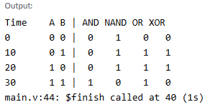
Waveform:
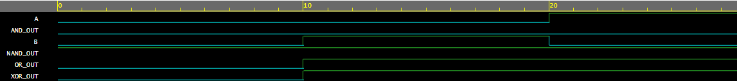

2. Design and simulate a half adder and a full adder

Source Code:
module half_adder (
input a, b,
output sum, carry
);
assign sum = a ^ b;
assign carry = a & b;
endmodule

module full_adder (
input a, b, cin,
output sum, cout
);
assign sum = a ^ b ^ cin;
assign cout = (a & b) | (b & cin) | (a & cin);
endmodule

Test Bench:
module tb_adders;
reg a, b, cin;
wire sum_ha, carry_ha;
wire sum_fa, cout_fa;

reg [3:0] a4, b4;
wire [3:0] sum4;
wire cout4;

half_adder ha_uut (.a(a), .b(b), .sum(sum_ha), .carry(carry_ha));
full_adder fa_uut (.a(a), .b(b), .cin(cin), .sum(sum_fa), .cout(cout_fa));

initial begin

$display("\n--- Half Adder ---");
$display("a | b | sum | carry");
$display("-----|-------|-------");
a = 0; b = 0; #10;
$display("%b | %b | %b | %b", a, b, sum_ha, carry_ha);
a = 0; b = 1; #10;
$display("%b | %b | %b | %b", a, b, sum_ha, carry_ha);
a = 1; b = 0; #10;
$display("%b | %b | %b | %b", a, b, sum_ha, carry_ha);
a = 1; b = 1; #10;
$display("%b | %b | %b | %b", a, b, sum_ha, carry_ha);

$display("\n--- Full Adder ---");
$display("a | b | cin | sum | cout");
$display("---|---|-----|-----|-----");
a = 0; b = 0; cin = 0; #10;
$display("%b | %b | %b | %b | %b", a, b, cin, sum_fa, cout_fa);
a = 0; b = 1; cin = 0; #10;
$display("%b | %b | %b | %b | %b", a, b, cin, sum_fa, cout_fa);
a = 1; b = 1; cin = 1; #10;
$display("%b | %b | %b | %b | %b", a, b, cin, sum_fa, cout_fa);
a = 1; b = 0; cin = 1; #10;
$display("%b | %b | %b | %b | %b", a, b, cin, sum_fa, cout_fa);

end
endmodule
Output:
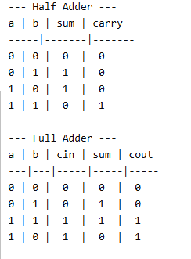

Waveform:
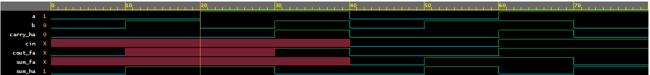

3. Design and simulate Multiplexers.

Source Code:
module mux2x1(
input I0,
input I1,
input S,
output Y
);

assign Y = S ? I1 : I0;

endmodule

Test Bench:
module tb_mux2x1;

reg I0, I1, S;
wire Y;

mux2x1 uut(
.I0(I0),
.I1(I1),
.S(S),
.Y(Y)
);

initial begin

$display("I0 I1 S | Y");

$monitor("%b %b %b | %b",
I0,I1,S,Y);

I0=0; I1=1; S=0;
#10 S=1;

#10 I0=1; I1=0; S=0;
#10 S=1;

#10 $finish;

end

endmodule
Output:
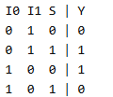

Waveform:
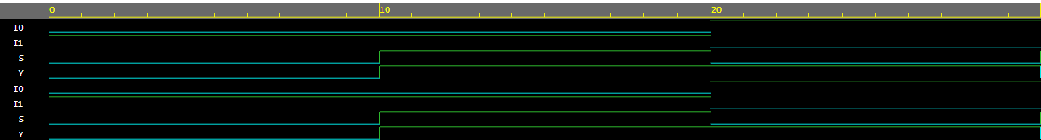

4. Design and simulate Priority Encoders
Source Code:
module priority_encoder(
input I0,I1,I2,I3,
output reg [1:0] Y
);

always @(*) begin
if (I3) Y = 2'b11;
else if (I2) Y = 2'b10;
else if (I1) Y = 2'b01;
else if (I0) Y = 2'b00;
else Y = 2'b00;
end

endmodule

Test Bench:
module tb_priority_encoder;

reg I0,I1,I2,I3;
wire [1:0] Y;

priority_encoder uut(I0,I1,I2,I3,Y);

initial begin
$monitor("I3I2I1I0=%b%b%b%b -> Y=%b", I3,I2,I1,I0,Y);

I0=0; I1=0; I2=0; I3=1;
#10 I3=0; I2=1;
#10 I2=0; I1=1;
#10 I1=0; I0=1;
#10 $finish;
end

endmodule
Output:
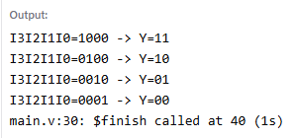
Waveform:
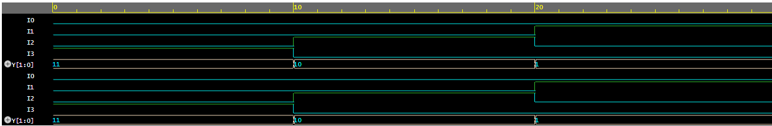

5. Design and simulate an ALU
Source Code:
module alu(
input [3:0] A,B,
input [1:0] Sel,
output reg [3:0] Y
);

always @(*) begin
case(Sel)
2'b00: Y = A + B;
2'b01: Y = A - B;
2'b10: Y = A & B;
2'b11: Y = A | B;
endcase
end

endmodule

Test Bench:
module tb_alu;

reg [3:0] A,B;
reg [1:0] Sel;
wire [3:0] Y;

alu uut(A,B,Sel,Y);

initial begin
$monitor("A=%d B=%d Sel=%b Y=%d",A,B,Sel,Y);

A=5; B=3;
Sel=0; #10;
Sel=1; #10;
Sel=2; #10;
Sel=3; #10;

$finish;
end

endmodule
Output:
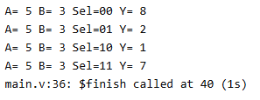
Waveform:
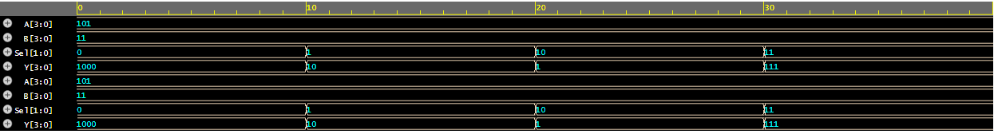

6. Design and simulate a D flip-flop without reset
Source Code:
module d_flipflop_no_reset (
input d, clk,
output reg q, q_bar
);

always @(posedge clk) begin
q <= d;
q_bar <= ~d;
end

endmodule

Test Bench:
module tb_d_flipflop_no_reset;

reg d, clk;
wire q, q_bar;

d_flipflop_no_reset uut (
.d(d),
.clk(clk),
.q(q),
.q_bar(q_bar)
);

initial begin
$dumpfile("dump.vcd");
$dumpvars(0, tb_d_flipflop_no_reset);
end

initial begin
clk = 0;
forever #5 clk = ~clk;
end

initial begin

$display("Time | clk | d | q | q_bar");

$monitor("%0t\t | %b | %b | %b | %b",
$time, clk, d, q, q_bar);

d = 0; #10;
d = 1; #10;
d = 0; #10;
d = 1; #10;
d = 1; #10;
d = 0; #10;

#10;
$finish;
end

endmodule

Output:
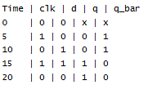

Waveform:
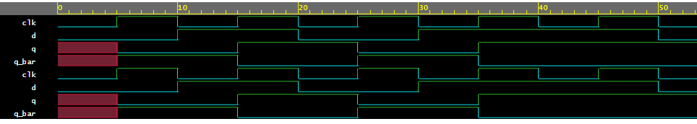

7. Design and simulate a synchronous and asynchronous D flip-flop
Source Code:
`timescale 1ns/1ps

module dff_synchronous(
input clk,
input reset,
input d,
output reg q
);

always @(posedge clk)
begin
if(reset)
q <= 1'b0;
else
q <= d;
end

endmodule

Test Bench:
`timescale 1ns/1ps

module test;

reg clk;
reg reset;
reg d;
wire q;

// DUT
dff_synchronous uut(
.clk(clk),
.reset(reset),
.d(d),
.q(q)
);

// Clock Generation
initial begin
clk = 0;
forever #5 clk = ~clk;
end

// Waveform Dump
initial begin
$dumpfile("dump.vcd");
$dumpvars(0, test);
end

// Stimulus
initial begin

$display("Time\tclk\treset\td\tq");
$monitor("%0t\t%b\t%b\t%b\t%b",
$time, clk, reset, d, q);

reset = 1;
d = 0;

#10;
reset = 0;

d = 1; #10;
d = 0; #10;
d = 1; #10;
d = 0; #10;

#20;
$finish;

end

endmodule
Output:
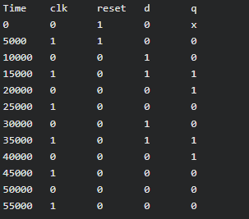
Waveform:
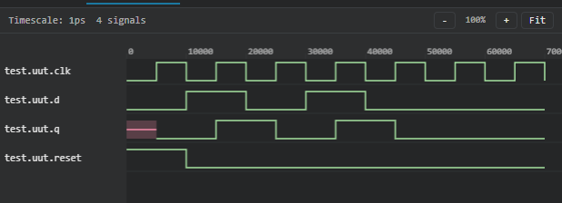

Source Code:
`timescale 1ns/1ps

module dff_asynchronous(
input clk,
input reset,
input d,
output reg q
);

always @(posedge clk or posedge reset)
begin
if(reset)
q <= 1'b0;
else
q <= d;
end

endmodule

Test Bench:
`timescale 1ns/1ps

module test;

reg clk;
reg reset;
reg d;
wire q;

dff_asynchronous uut(
.clk(clk),
.reset(reset),
.d(d),
.q(q)
);

// Clock generation
initial begin
clk = 0;
forever #5 clk = ~clk;
end

// VCD dump
initial begin
$dumpfile("dump.vcd");
$dumpvars(0, test);
end

// Stimulus
initial begin

$display("Time\tclk\treset\td\tq");
$monitor("%0t\t%b\t%b\t%b\t%b",
$time, clk, reset, d, q);

reset = 1;
d = 0;

#5 reset = 0;

d = 1; #10;
d = 0; #10;

// Asynchronous Reset
reset = 1; #5;
reset = 0;

d = 1; #10;
d = 0; #10;

#20;
$finish;

end

endmodule

Output:
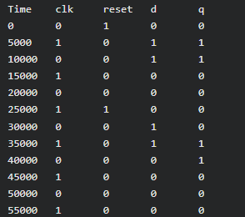
Waveform:
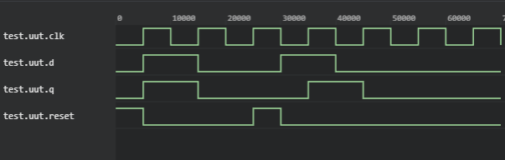

8. Design and simulate JK FlipFlop
Source Code:
`timescale 1ns/1ps

module jk_flipflop(
input clk,
input reset,
input j,
input k,
output reg q
);

always @(posedge clk or posedge reset)
begin
if(reset)
q <= 1'b0;
else
begin
case({j,k})

2'b00: q <= q; // No Change

2'b01: q <= 1'b0; // Reset

2'b10: q <= 1'b1; // Set

2'b11: q <= ~q; // Toggle

endcase
end
end

endmodule

Test Bench:
`timescale 1ns/1ps

module test;

reg clk;
reg reset;
reg j;
reg k;

wire q;

jk_flipflop uut(
.clk(clk),
.reset(reset),
.j(j),
.k(k),
.q(q)
);

// Clock Generation
initial begin
clk = 0;
forever #5 clk = ~clk;
end

// Waveform Dump
initial begin
$dumpfile("dump.vcd");
$dumpvars(0, test);
end

// Display Output
initial begin

$display("Time\tclk\treset\tJ\tK\tQ");
$monitor("%0t\t%b\t%b\t%b\t%b\t%b",
$time, clk, reset, j, k, q);

// Reset
reset = 1;
j = 0;
k = 0;

#10;
reset = 0;

// 00 → No Change
j = 0; k = 0;
#10;

// 01 → Reset
j = 0; k = 1;
#10;

// 10 → Set
j = 1; k = 0;
#10;

// 11 → Toggle
j = 1; k = 1;
#10;

// Toggle Again
#10;

// Set
j = 1; k = 0;
#10;

// Reset
j = 0; k = 1;
#10;

$finish;

end

endmodule
Output:
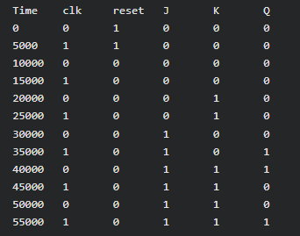
Waveform:
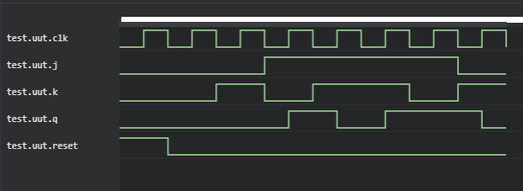

9. Design and simulate SISO, SIPO, PISO, PIPO.
Source Code:
module shift_register_ic (
input clk,
input reset,
input [1:0] mode,
input serial_in,
input [3:0] parallel_in,
input load,

output reg serial_out,
output reg [3:0] parallel_out
);

reg [3:0] shift_reg;

always @(posedge clk or negedge reset) begin
if (!reset) begin
shift_reg <= 4'b0000;
serial_out <= 0;
end
else begin
case (mode)

// SISO
2'b00: begin
shift_reg <= {shift_reg[2:0], serial_in};
serial_out <= shift_reg[3];
end

// SIPO
2'b01: begin
shift_reg <= {shift_reg[2:0], serial_in};
parallel_out <= shift_reg;
end

// PISO
2'b10: begin
if (load)
shift_reg <= parallel_in;
else
shift_reg <= {shift_reg[2:0], 1'b0};

serial_out <= shift_reg[3];
end

// PIPO
2'b11: begin
if (load)
shift_reg <= parallel_in;
else
shift_reg <= shift_reg;

parallel_out <= shift_reg;
end

endcase
end
end

endmodule

Test Bench:
`timescale 1ns/1ps

module tb_shift_register_ic;

reg clk;
reg reset;
reg [1:0] mode;
reg serial_in;
reg [3:0] parallel_in;
reg load;

wire serial_out;
wire [3:0] parallel_out;

// DUT (Device Under Test)
shift_register_ic uut (
.clk(clk),
.reset(reset),
.mode(mode),
.serial_in(serial_in),
.parallel_in(parallel_in),
.load(load),
.serial_out(serial_out),
.parallel_out(parallel_out)
);

// Clock generation (10ns period)
initial begin
clk = 0;
forever #5 clk = ~clk;
end

// VCD dump for EDA Playground
initial begin
$dumpfile("shift_register_ic.vcd");
$dumpvars(0, tb_shift_register_ic);
end

initial begin
$display("\n===== SHIFT REGISTER IC TEST =====\n");

reset = 0;
mode = 2'b00;
serial_in = 0;
parallel_in = 0;
load = 0;

#10;
reset = 1;

$display("\n--- SISO MODE ---");
mode = 2'b00;

serial_in = 1; #10;
serial_in = 0; #10;
serial_in = 1; #10;
serial_in = 1; #10;

$display("\n--- SIPO MODE ---");
mode = 2'b01;

serial_in = 1; #10;
serial_in = 0; #10;
serial_in = 1; #10;
serial_in = 1; #10;

$display("\n--- PISO MODE ---");
mode = 2'b10;

parallel_in = 4'b1010;
load = 1; #10;
load = 0;

#10;
#10;
#10;
#10;

$display("\n--- PIPO MODE ---");
mode = 2'b11;

parallel_in = 4'b1101;
load = 1; #10;
load = 0;

#10;
#10;
#10;

$display("\n===== SIMULATION COMPLETE =====\n");
$finish;
end

endmodule

Waveform:
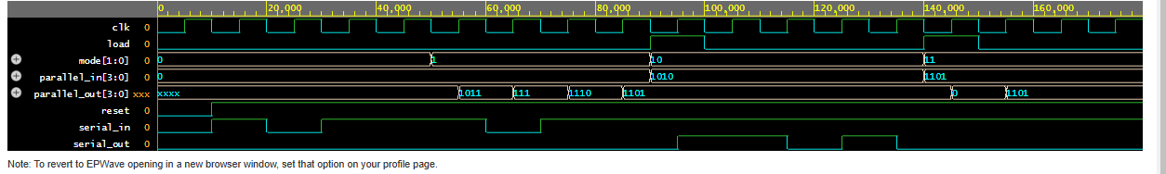

10. Design and simulate up and down counters with different recent strategies for up and down counters.
Source Code:
module up_down_counter (
input clk,
input rst,
input up_down, // 1 = Up Count, 0 = Down Count
output reg [2:0] count
);

always @(posedge clk or posedge rst)
begin
if (rst)
count <= 3'b000;

else begin

if (up_down) begin
// Up Counter
if (count == 3'b111)
count <= 3'b000;
else
count <= count + 1;
end

else begin
// Down Counter
if (count == 3'b000)
count <= 3'b111;
else
count <= count - 1;
end

end
end

endmodule

Test Bench:
`timescale 1ns/1ps

module tb_up_down_counter;

reg clk;
reg rst;
reg up_down;

wire [2:0] count;

// DUT
up_down_counter uut (
.clk(clk),
.rst(rst),
.up_down(up_down),
.count(count)
);

// VCD Dump for EPWave
initial begin
$dumpfile("dump.vcd");
$dumpvars(0, tb_up_down_counter);
end

// Clock Generation (10ns Period)
initial begin
clk = 0;
forever #5 clk = ~clk;
end

// Monitor
initial begin
$monitor("T=%0t | rst=%b | up_down=%b | count=%b (%0d)",
$time, rst, up_down, count, count);
end

// Test Stimulus
initial begin

// Initialize
rst = 1;
up_down = 1;

// Reset Active
#12;
rst = 0;

$display("\n===== UP COUNTING =====");

up_down = 1;

repeat(8)
@(posedge clk);

$display("\n===== DOWN COUNTING =====");

up_down = 0;

repeat(8)
@(posedge clk);

//-----------------------------------
// RESET AGAIN
//-----------------------------------
$display("\n===== RESET =====");

rst = 1;
#10;
rst = 0;

repeat(5)
@(posedge clk);

$display("\n===== SIMULATION COMPLETE =====");

#10;
$finish;

end

endmodule
Output:
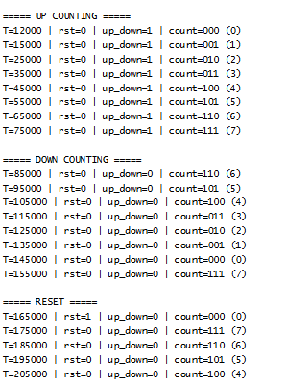
Waveform:
